Group: Victoria, Nelly, Mher

#Visualisation of data – ggplot

Code:

ggplot(dt1, aes(dt1$Treatment, dt1$Weight, col = dt1$Diet)) +

geom_point() +

labs(x = "Treatment", y = "Weight", colour = "Diet") +

geom_jitter()

Result:

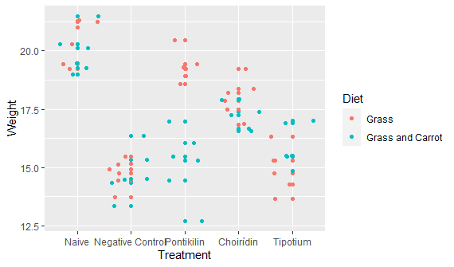

#Data analysis

T-tests: comparing negative control group with each treatment&diet groups.

naive<-filter(dt1, Treatment=="Naive")%>%select(Weight)%>%unlist

negative<-filter(dt1, Treatment=="Negative Control")%>%select(Weight)%>%unlist

ttset1<-t.test(naive, negative) **#p less than 0.05**

pontg<-filter(dt1, Treatment=="Pontikilin", Diet=="Grass")%>%select(Weight)%>%unlist

ttest2<-t.test(pontg, negative) **#p less than 0.05 p-value = 1.121e-08**

pontc<-filter(dt1, Treatment=="Pontikilin", Diet=="Grass and Carrot")%>%select(Weight)%>%unlist

ttest3<-t.test(pontc, negative) **#p more than 0.05**

choig<-filter(dt1, Treatment=="Choirídin", Diet=="Grass")%>%select(Weight)%>%unlist

t.test4<-t.test(choig, negative) **#p less than 0.05 p-value = 1.162e-05**

choic<-filter(dt1, Treatment=="Choirídin", Diet=="Grass and Carrot")%>%select(Weight)%>%unlist

t.test5<-t.test(choic, negative) **#p less than 0.05 p-value = 3.126e-06**

tipg<-filter(dt1, Treatment=="Tipotium", Diet=="Grass")%>%select(Weight)%>%unlist

t.test6<-t.test(tipg, negative) **#p more than 0.05**

tipc<-filter(dt1, Treatment=="Tipotium", Diet=="Grass and Carrot")%>%select(Weight)%>%unlist

t.test7<-t.test(tipc, negative) **#p less than 0.05 p-value = 0.02444**

ANOVA:

try2<-aov(Weight~Treatment*Diet, data=dt1)

summary(try2)



#Results and discussion

Judging from the p-values, the most effective drug was Pontikilin with Grass diet. However, as the patient’s dietary preference is carrot, a drug with carrot diet combination may work better. In this case, two drugs, Choirídin and Tipotium produced an effect with Carrot+Grass diet. As the p-value for Choirídin is noticeably lower than for Tipotium (3.126e-06 vs. 0.02444), Choiridin & Grass+Carrot diet may work the best.

ANOVA test also reported that drugs with diets significantly increased mice’s weights.

#Limitations

* We have tested the treatments + diets only on mice and rats, however, our patient is a guinea pig. The guinea pig may react differently to the compounds than mice.
* We have analyzed the effectiveness of drugs only by measuring mice’s weights, and did not take nay other measurements.
* We had a limited amount of mice we could test on, i.e. 3 mice for each specific drug + diet.
* We didn’t perform any *in silico* and *in vitro experiments*.
* We haven’t tried combining the effective treatments with each other, i.e. combination therapy.
* We did not take into account the mice’s sex, which may play a factor in their drug response.
* We took the mice from the basement, they may other underlying health conditions, which could effect their conditions.